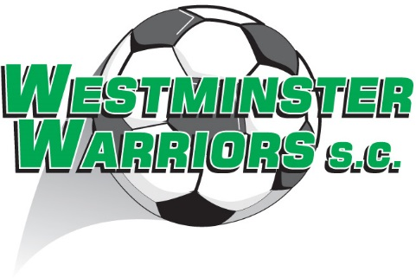

Can I sponsor or make a donation to the club?

As a community club who rely on a large team of volunteers, we are always open to any support individuals or organisations/companies can make. If you are interested in knowing more please contact our Secretary or President.

